**Proposal: Visualizing Wine Reviews**

**Topic and Rationale**

Understanding wine can be intimidating. Inputs to winemaking (grape variety, terroir, winery, etc.) and characteristics of the wine vary widely. To better understand the current state of winemaking, we plan to visualize information about wines that have recently been reviewed by professional wine critics. We hope this sampling will provide insight into at least a few basic characteristics of the current winemaking landscape.

**Questions Potentially Explored**

* How do wine brands vary across key attributes/factors (price, score, etc.)?
* Where are the most wines are produced?
* Where is the user’s favorite type of wine most frequently made?
* How, if at all, does climate affect wine production?
* Are wines priced evenly across the globe?
* How are price, qualitative reviews, and ratings related?

**Dataset**

We decided to use this dataset because it contains recent wine review data (2017). It includes a variety of geographic and qualitative descriptive data, such as the winery, country and region of the wines, as well the number of points received by each wine. It also is accessible via API and website download.

Sample of Data in CSV:



**Visualizations**

**Inspirational Visualization #1**: Our first visualization is of a dashboard that will allow the user to select the wine variety and see price, ratings, and country of production information in chart and table format.

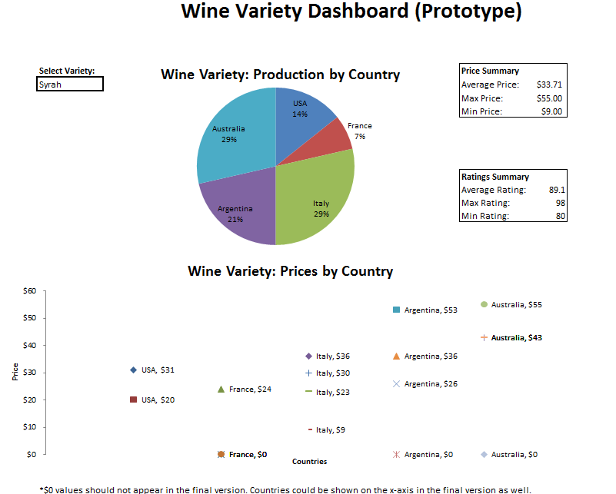

We are also considering a geodata driven map of world with user ability to drill into different data points similar to visualizations 2 & 3 below. Information will be displayed by country. The user can select "Wine Points" or "Wine Price" to dynamically adjust the map visuals (adjustment type will likely be a color scale that shows the countries average value for the selected variable). They can further hover over a country to see additional data, such as average, max and min values for the selected variable.

**Inspirational Visualization #2**: World map with countries that have wine reviews are highlighted. The user can select whether to change color scale based on Wine Price or Wine Points (colors not changing in this "inspirational" image, but could on our site).

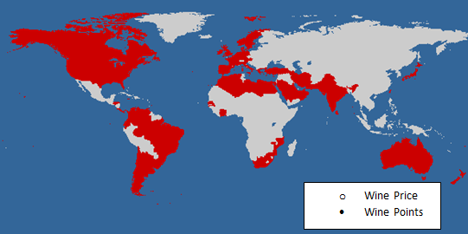

**Inspirational Visualization #3**: This is similar to what could be displayed at the country level when a user selects Wine Price or Wine Points. The color for each country will adjust based on the level and scale of the data point selected.

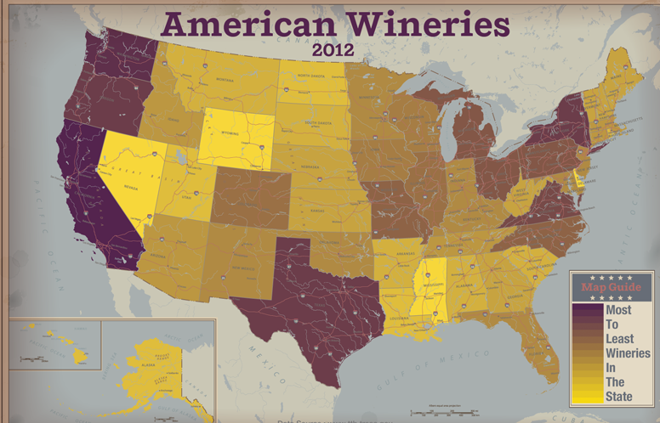

**Expected Software Utilized**

* HTML/ CSS
* JavaScript (Plotly, Leaflet, etc.)
* Python
* Flask
* Database Tools (SQL Alchemy, SQL/ MySQL, MongoDB)

GitHub Repository: https://github.com/ksk4uever/Group-Project2/